**STRING METHODS**

**Introduction**

Do you have a gigantic string that you need to parse for information? Do you need to sanitize a users input to work in a function? Do you need to be able to generate outputs with variable values? All of these things can be accomplished with *string methods*!

Python comes with built-in *string methods* that gives you the power to perform complicated tasks on strings very quickly and efficiently. These string methods allow you to change the case of a string, split a string into many smaller strings, join many small strings together into a larger string, and allow you to neatly combine changing variables with string outputs.

In the previous lesson, you worked with len(), which was a *function* that determined the number of characters in a string. This, while similar, was NOT a string method. String methods all have the same syntax:

string_name.string_method(arguments)

Unlike len(), which is called with a string as its argument, a string method is called at the end of a string and each one has its own method specific arguments.

**Instructions**

The diagram shows all of the string methods you can expect to learn in this lesson. Take a quick look at them and then let’s get started!

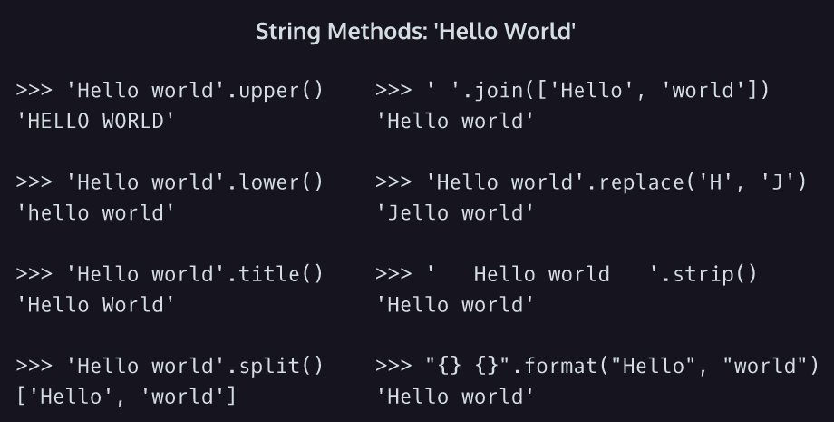

**Formatting Methods**

There are three string methods that can change the casing of a string. These are .lower(), .upper(), and .title().

* .lower() returns the string with all lowercase characters.
* .upper() returns the string with all uppercase characters.
* .title() returns the string in title case, which means the first letter of each word is capitalized.

Here’s an example of .lower() in action:

favorite_song = 'SmOoTH'  
favorite_song_lowercase = favorite_song.lower()  
print(favorite_song_lowercase)  
# => 'smooth'

Every character was changed to lowercase! It’s important to remember that string methods can only **create** new strings, they do not change the original string.

print(favorite_song)  
# => 'SmOoTH'

See, it’s still the same! These string methods are great for sanitizing user input and standardizing the formatting of your strings.

**Instructions**

**1.**

You’re a programmer working for an organization that is trying to digitize and store poetry called *Preserve the Verse*.

You’ve been given two strings, the title of a poem and its author, and have been asked to reformat them slightly to fit the conventions of the organization’s database.

Make poem_title have title case and save it to poem_title_fixed.

Checkpoint 2 Passed

**2.**

Print poem_title and poem_title_fixed.

How did the string change?

Checkpoint 3 Passed

**3.**

The organization’s database also needs the author’s name to be uppercase only.

Make poem_author uppercase and save it to poem_author_fixed.

Checkpoint 4 Passed

**4.**

Print poem_author and poem_author_fixed.

Again, how did the string change?

**script.py**

poem_title = "spring storm"

poem_author = "William Carlos Williams"

poem_title_fixed = poem_title.title()

print(poem_title)

print(poem_title_fixed)

poem_author_fixed = poem_author.upper()

print(poem_author)

print(poem_author_fixed)

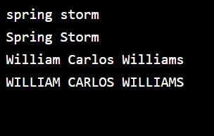

**Splitting Strings**

.upper(), .lower(), and .title() all are performed on an existing string and produce a string in return. Let’s take a look at a string method that returns a different object entirely!

.split() is performed on a string, takes one argument, and returns a list of substrings found between the given argument (which in the case of .split() is known as the delimiter). The following syntax should be used:

string_name.split(delimiter)

If you do not provide an argument for .split() it will default to splitting at spaces.

For example, consider the following strings:

man_its_a_hot_one = "Like seven inches from the midday sun"  
print(man_its_a_hot_one.split())  
# => ['Like', 'seven', 'inches', 'from', 'the', 'midday', 'sun']

.split returned a list with each word in the string. Important to note: if we run .split() on a string with no spaces, we will get the same string in return.

**Instructions**

**1.**

In the code editor is a string of the first line of the poem *Spring Storm* by William Carlos Williams.

Use .split() to create a list called line_one_words that contains each word in this line of poetry.

**script.py**

line_one = "The sky has given over"

line_one_words = line_one.split()

print(line_one_words)

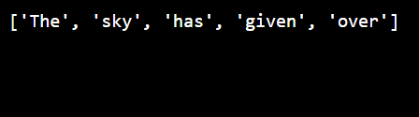

**Splitting Strings II**

If we provide an argument for .split() we can dictate the character we want our string to be split on. This argument should be provided as a string itself.

Consider the following example:

greatest_guitarist = "santana"  
print(greatest_guitarist.split('n'))  
# => ['sa', 'ta', 'a']

We provided 'n' as the argument for .split() so our string “santana” got split at each 'n' character into a list of three strings.

What do you think happens if we split the same string at 'a'?

print(greatest_guitarist.split('a'))  
# => ['s', 'nt', 'n', '']

Notice that there is an unexpected extra '' string in this list. When you split a string on a character that it also ends with, you’ll end up with an empty string at the end of the list.

You can use *any* string as the argument for .split(), making it a versatile and powerful tool.

**Instructions**

**1.**

Your boss at the Poetry organization sent over a bunch of author names that he wants you to prepare for importing into the database. Annoyingly, he sent them over as a long string with the names separated by commas.

Using .split() and the provided string, create a list called author_names containing each individual author name as it’s own string.

Checkpoint 2 Passed

**2.**

Great work, but now it turns out they didn’t want poet’s first names (why didn’t they just say that the first time!?)

Create another list called author_last_names that only contains the last names of the poets in the provided string.

Checkpoint 3 Passed

Hint

There are several ways to do this, but one way is to iterate through the list you created in part one and use .split(), negative indexing, and .append() to construct the new list.

**script.py**

authors = "Audre Lorde,Gabriela Mistral,Jean Toomer,An Qi,Walt Whitman,Shel Silverstein,Carmen Boullosa,Kamala Suraiyya,Langston Hughes,Adrienne Rich,Nikki Giovanni"

author_names = authors.split(',')

print(author_names)

subresult = []

author_last_names = []

for author in author_names:

  subresult.append(author.split(' '))

for author in subresult:

  author_last_names.append(author[1])

print(author_last_names)

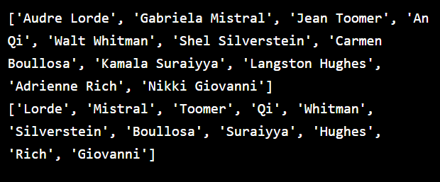

**Splitting Strings III**

We can also split strings using *escape sequences*. Escape sequences are used to indicate that we want to split by something in a string that is not necessarily a character. The two escape sequences we will cover here are

* \n Newline
* \t Horizontal Tab

Newline or \n will allow us to split a multi-line string by line breaks and \t will allow us to split a string by tabs. \t is particularly useful when dealing with certain datasets because it is not uncommon for data points to be separated by tabs.

Let’s take a look at an example of splitting by an escape sequence:

smooth_chorus = \  
"""And if you said, "This life ain't good enough."  
I would give my world to lift you up  
I could change my life to better suit your mood  
Because you're so smooth"""  
   
chorus_lines = smooth_chorus.split('\n')  
   
print(chorus_lines)

This code is splitting the multi-line string at the newlines (\n) which exist at the end of each line and saving it to a new list called chorus_lines. Then it prints chorus_lines which will produce the output

['And if you said, "This life ain\'t good enough."', 'I would give my world to lift you up', 'I could change my life to better suit your mood', "Because you're so smooth"]

The new list contains each line of the original string as its own smaller string. Also, notice that Python automatically escaped the ' character in the first line and adjusted to double quotation marks to allow the apostrophe on last line when it created the new list.

**Instructions**

**1.**

The organization has sent you over the full text for William Carlos Williams poem *Spring Storm*. They want you to break the poem up into its individual lines.

Create a list called spring_storm_lines that contains a string for each line of *Spring Storm*.

Checkpoint 2 Passed

Hint

You will have to use .split() and the escape character for a newline, \n.

**script.py**

spring_storm_text = \

"""The sky has given over

its bitterness.

Out of the dark change

all day long

rain falls and falls

as if it would never end.

Still the snow keeps

its hold on the ground.

But water, water

from a thousand runnels!

It collects swiftly,

dappled with black

cuts a way for itself

through green ice in the gutters.

Drop after drop it falls

from the withered grass-stems

of the overhanging embankment."""

spring_storm_lines = spring_storm_text.split('\n')

print(spring_storm_lines)

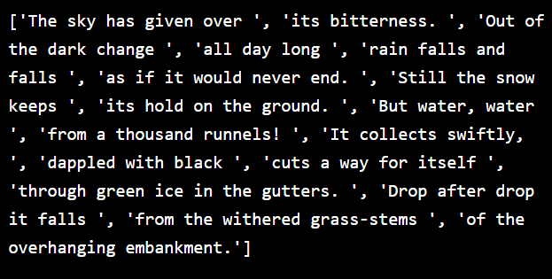

**Joining Strings**

Now that you’ve learned to break strings apart using .split(), let’s learn to put them back together using .join(). .join() is essentially the opposite of .split(), it *joins* a list of strings together with a given delimiter. The syntax of .join() is:

'delimiter'.join(list_you_want_to_join)

Now this may seem a little weird, because with .split() the argument was the delimiter, but now the argument is the list. This is because *join* is still a string method, which means it has to act on a string. The string .join() acts on is the delimiter you want to join with, therefore the list you want to join has to be the argument.

This can be a bit confusing, so let’s take a look at an example.

my_munequita = ['My', 'Spanish', 'Harlem', 'Mona', 'Lisa']  
print(' '.join(my_munequita))  
# => 'My Spanish Harlem Mona Lisa'

We take the list of strings, my_munequita, and we joined it together with our delimiter, ' ', which is a space. The space is important if you are trying to build a sentence from words, otherwise, we would have ended up with:

print(''.join(my_munequita))  
# => 'MySpanishHarlemMonaLisa'

**Instructions**

**1.**

You’ve been provided with a list of words from the first line of Jean Toomer’s poem [*Reapers*](https://www.poetryfoundation.org/poems/46405/reapers).

Use .join() to combine these words into a sentence and save that sentence as the string reapers_line_one.

Checkpoint 2 Passed

Hint

Make sure that you are running join on a space, ' ', otherwise you’ll mash the words together.

**script.py**

reapers_line_one_words = ["Black", "reapers", "with", "the", "sound", "of", "steel", "on", "stones"]

reapers_line_one = ' '.join(reapers_line_one_words)

print(reapers_line_one)

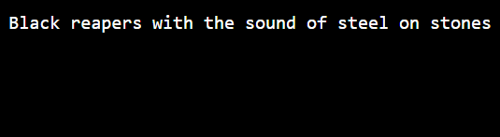

**Joining Strings II**

In the last exercise, we joined together a list of words using a space as the delimiter to create a sentence. In fact, you can use any string as a delimiter to join together a list of strings. For example, if we have the list

santana_songs = ['Oye Como Va', 'Smooth', 'Black Magic Woman', 'Samba Pa Ti', 'Maria Maria']

We could join this list together with ANY string. One often used string is a comma , because then we can create a string of *comma separated variables*, or CSV.

santana_songs_csv = ','.join(santana_songs)  
print(santana_songs_csv)  
# => 'Oye Como Va,Smooth,Black Magic Woman,Samba Pa Ti,Maria Maria'

You’ll often find data stored in CSVs because it is an efficient, simple file type used by popular programs like Excel or Google Spreadsheets.

You can also join using *escape sequences* as the delimiter. Consider the following example:

smooth_fifth_verse_lines = ['Well I\'m from the barrio', 'You hear my rhythm on your radio', 'You feel the turning of the world so soft and slow', 'Turning you \'round and \'round']  
   
smooth_fifth_verse = '\n'.join(smooth_fifth_verse_lines)  
   
print(smooth_fifth_verse)

This code is taking the list of strings and joining them using a newline \n as the delimiter. Then it prints the result and produces the output:

Well I'm from the barrio  
You hear my rhythm on your radio  
You feel the turning of the world so soft and slow  
Turning you 'round and 'round

**Instructions**

**1.**

You’ve been given a list, winter_trees_lines, that contains all the lines to William Carlos Williams poem, *Winter Trees*. You’ve been asked to join together the strings in the list together into a single string that can be used to display the full poem. Name this string winter_trees_full.

Print your result to the terminal. Make sure that each line of the poem appears on a new line in your string.

Checkpoint 2 Passed

Hint

Use \n, the escape character for a line break.

**script.py**

winter_trees_lines = ['All the complicated details', 'of the attiring and', 'the disattiring are completed!', 'A liquid moon', 'moves gently among', 'the long branches.', 'Thus having prepared their buds', 'against a sure winter', 'the wise trees', 'stand sleeping in the cold.']

winter_trees_full = '\n'.join(winter_trees_lines)

print(winter_trees_full)

